PREFACE BY THE PILOTS
of the 2018 Île-de-France Workshop

Bertrand Warnier, Founder of les Ateliers de Cergy and workshop mentor:
Urban planning is part of an ill-defined but essential interface between planning and architecture; cities are by no means a sum their objects but a specific process which must be constantly updated... and which is capable of integrating the unexpected.

It just so happens that YOU—the young generation to which you belong and represent—are in one of these unexpected situations, that of deciding in the place of those who are in authority today.

What are you going to do for a month in Cergy-Pontoise?
What are you going to do that will enable you to find the right balances?
Simply, what should you expect?

Exchanges between cultures, disciplines, backgrounds and individual temperaments will be essential: What will you bring to the table? What visions or perspectives? What institutional backgrounds? What principles? What convictions? Will they be drawn from examples gleaned here or there?

This means talking about a metropolis, with a capital M—its lifestyles, living environments, and so on. But also, how you and others want to construct your/their life(s).

You inherit city centres, urban peripheries, rural areas, hamlets and villages, suburbs, historic or new towns, etc.—whether they be continuous or fragmented social and geographic fabrics, integrated or independent agricultural structures—but also a singular
and not very glorious ecological situation.

Is this the vernacular of a metropolis? One where two extreme scales are confronted: that of the habitat and that of the greater geography and new economies?

What about places, urban dwellers, signs of the 21st century? What about the presence of water, vegetation, birds, and also the other forms (of LIFE) generated by new energies and new technologies?

There is, however, one requirement: You must find a balance between what you think and what your partners think... as well as what the citizens you represent think.

The document you have in your hands is the result of extensive research, condensed to the most essential information to make it an easy tool to use. It is the work of people who have donated their time (our thanks to them), who can enlighten you—not direct you—on particular points.

They are waiting for your thoughts and have a strong desire to see what emerges.

Bertrand Warnier

Solenne Sari, pilote, Archjtec urban planner and workshop pilot :

During this year devoted to the preparation of the workshop, the following questions structured my reflections: How can we talk about LIFE in the future of metropolitan areas? How can such a broad subject be dealt with without running the risk of departing
from it? How can we be nourished by the multiple studies that metropolisation generates without letting ourselves be invaded by our professional reflexes; without letting ourselves be guided by the regulatory, institutional or contractual frameworks that guide
the organisation of cities; without getting caught up in the preconceived notion that animate public debate?

The answer: change the focus of attention by putting LIFE at the centre of the debate! In fact, perspectives will be intertwined and juxtaposed, they will be starting block for the greater reflection: What could be more difficult than to reach a consensus on the
modalities of LIFE? A pioneering concept of existence, LIFE has vague, vast, multiple and unrestrained limits... its image reflects the boundaries of the lived territory of the Paris metropolitan area, the workshop’s study area.

“One’s real life is so often the life that one does not lead,” wrote Oscar Wilde. It is therefore up to this workshop to lay the foundations of real life, the one that is both possible and desirable, so that inhabitants of the Paris metropolitan area can envision
the future, that of 2050.

While the city of the 19th century was organised around a creationist logic, the city of the 21st century is reflected by a logic of flow combined with a logic of the individual. We need to move from the idea of place to that of use, paying attention to the core
issue of mobility along with the two great contemporary revolutions that are climate shock and technological breakthroughs.

Based on the guiding elements set out in the topic document, numerous debates made it possible to develop a strong base of knowledge and accessible resources for this 36th international workshop. The series of metropolitan evening conferences allowed
us to hear from a number of specialists, researchers and technicians, who delved into the tenor of the various challenges facing the city of tomorrow.

How will the constant evolution of our usages and our mobility transform housing, work, the family unit? What transition is needed to avert the climate threat and reduce devastating inequalities? What effects does the digital revolution have on our relationship
with others and with the city in the metropolitan area?

We have illustrated in a transversal way the current and future evolutions of lifestyles and opened the subject towards the notion of the lived territory. In this respect, and notwithstanding the need to change paradigms if we want to make tomorrow’s city
liveable, a potential trap does exist of which participants should be aware: that of refusing to take into account the city as it is, including its set of contradictions and paradoxes. The metropolitan area is an ecosystem where positive and negative externalities coexist. This makes it complex but also rich; it is from this that innovation capacities are drawn, whether urban, cultural, social or economic.
The territory persists, it is certainly threatened on the one hand by the crucial issue of climate change and on the other hand by the social fractures that are tearing apart the urban fabric, but this allows us to anticipate the keys to its transformation. With each
site you visit, you will observe, listen and exchange, enriching the foundation of the data provided. Your responses must lead to a development process that allows for the impulse and valorisation of the territories from an intergenerational perspective.

But structuring the space to accommodate tomorrow’s LIFE also requires paying special attention to the articulation of scales: the “greater ” territory, the local, the nearby. Architecture, public spaces and the organisation of movements must resonate with
usages and allow for the inevitable transitions and adaptations brought on by the acceleration of different changes.

A strong idea must cross scales, intertwine places, reveal themes and usages, in order to be heard by all. There is no need, within this workshop, to present a finite form, but rather to explore how to reveal a process of making the city through a story that,
above all, invites collective sharing.

Solenne Sari

Jean-Michel Vincent, Engineer-Urban planner and workshop pilot :

You are the last generation who still has a chance to avert the threat of climate change. The next one, that of my grandchildren, can only accept the consequences of our collective inconsistencies.

In the span of a lifetime, the world’s population has tripled. The race, albeit legitimate, for prosperity and well-being has led us into a frantic race for fossil fuels to feed our machines: Nothing reprehensible, just eating every day to satisfy our hunger, being in
good health, living more comfortably, ensuring a better future for your children. Except that these fossil fuels emit gases that, in a month, spread across the earth and remain in the atmosphere for over a century, warming its surface. And we know it.

So what did we miss? Besides the greed, the desire for power by a few; maybe the frantic individualism of most of us and the share of generosity that goes with it? Who would ever think that they as an individual could change human nature? No, we were
surprised by our success, the speed with which we progressed.

All we need to do is look at life expectancy. From 1950 to today, life expectancy in France has risen from 50 to 80 years old. Reaching 50 years of age is today’s life expectancy in the poorest countries, 80 years in developed countries. For urban dwellers
the rate is 80% in developed countries, 50% for the whole world.

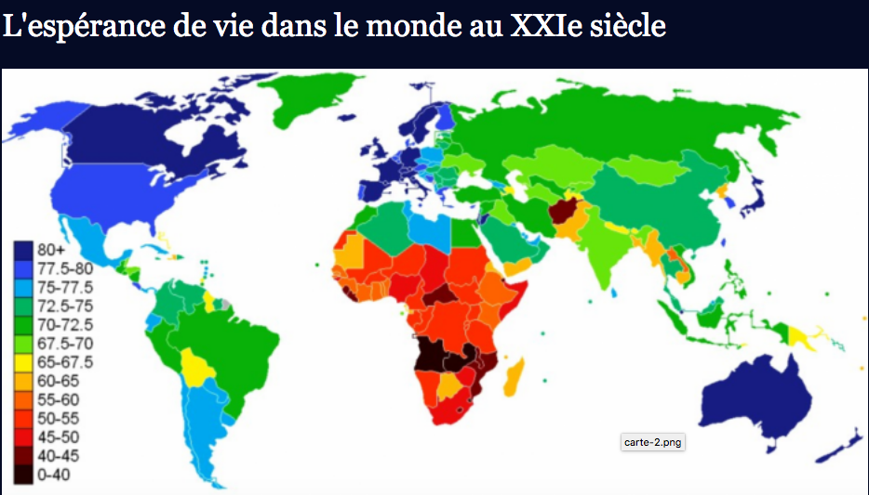

So what? The problem is that we have simply forgotten along the way that we are part of the biomass, of biodiversity; that the environment is not just the outside—something so easy to forget in the city—but the very source of life, a system of which we
are an integral part and with which we must be in balance or we will perish, if not humanity as a whole, then certainly civilisations. What would remain of our beautiful civilisations if, as during the 5 major climatic episodes of the last 500 million years since the appearance of life on earth, 60% to 90% of species disappeared? That is, between 4 and 6 billion human beings?

Could it be that we are just foolish enough to collectively trigger this disaster set for the early 2030s without any way to put out the fire?
For the workshop, it goes without saying that we have prepared the groundwork for you: 2 seminars, 4 metropolitan evenings and this immersion document into which you will have to dive. But for one month, in September, you will be the one who must take
the helm. Evaluate, propose, decide what life will or will not be in in the 21st century, from metropolitan areas to the countryside. And let it be known.

When you return home, you will hopefully be better equipped to add to a collective intelligence that we will also develop together. And you will use this experience to do it.

But is this all in vain? Do you know the legend of Sessa—the one who invented the game of chess—of the grain of wheat and of King Sheram, echoed in the tales of One Thousand and One Nights? Well, by persuading one person per week, who in turn
persuades another, we could reach 8 billion individuals in just 28 weeks.

Well-being versus blind enrichment, in time.

Jean-Michel Vincent, grandfather

